Postdoctoral Training Fellow:
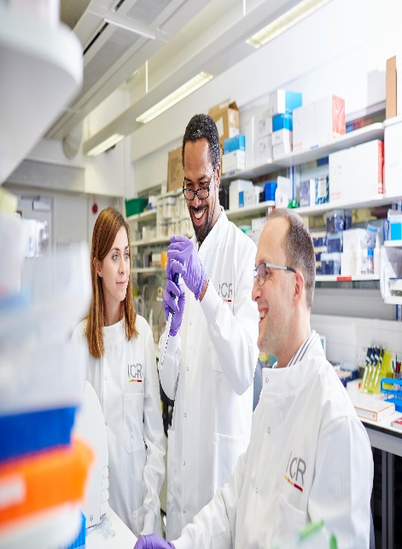

Cell Division
June 2026

The Institute of Cancer Research

About our organisation
We are one of the world’s most influential cancer research institutes with an outstanding record of achievement dating back more than 100 years. We are world leaders in identifying cancer genes, discovering cancer drugs and developing precision radiotherapy. Together with our hospital partner The Royal Marsden, we are rated in the top four centres for cancer research and treatment worldwide. As well as being a world-class institute, we are a college of the University of London.
We came second in the league table of university research quality compiled from the Research Excellence Framework (REF 2021). We have charitable status and rely on support from partner organisations, charities, donors and the general public. We have more than 1000 staff and postgraduate students across three sites – in Chelsea and Sutton.

Cell Division Group, Division of Cell and Molecular Biology, Chelsea
We are seeking a Postdoctoral Training Fellow to join the Cell Division Group led by Professor Jon Pines to investigate how cyclin B1-Cdk1 binding is regulated to form the trigger for mitosis.
The successful candidate will be part of a multidisciplinary research group studying cell-cycle regulation using a combination of molecular, cellular, biochemical, advanced cell imaging and proteomic approaches. The role will contribute to advancing our understanding of the fundamental processes that govern cell cycle mechanics and provide important implications for tissue morphogenesis and cancer biology.
Professor Jon Pines’s group is investigating how cells regulate cell division and divide genetic information evenly between cells when they separate, in particular how the machinery that controls cell division is regulated in space and time.
The Cell Division Group is embedded within the Cell and Molecualr Biology Division at the ICR’s Chester Beatty Laboratories in Chelsea, London. We have a highly supportive and interactive research environment, and state of the art facilities for cell biology, molecular biology, next-generation sequencing and structural biology. The great variety of disciplines at the ICR will ensure that you will be exposed to fantastic research and seminars from all types of backgrounds.

Our mission
is to make the discoveries that defeat cancer.

Our values
The ICR has a highly skilled and committed workforce, with a wide variety of roles, each requiring different skills. But whether you work as a researcher, or work as part of our corporate team, your work and behaviour is underpinned by these six values. They are what bring us together as one team - as 'One ICR'.

Pursuing excellence






We aspire to excellence in everything we do, and aim to be leaders in our field.

Acting with Integrity
We promote an open and honest environment that gives credit and acknowledges mistakes, so that our actions stand up to scrutiny.

Valuing all our people
We value the contribution of all our people, help them reach their full potential, and treat everyone with kindness and respect.

Working together
We collaborate with colleagues and partners to bring together different skills, resources and perspectives.

Leading innovation
We do things differently in ways that no one else has done before, and share the expertise and learning we gain.

Making a difference
We all play our part, doing a little bit more, a little bit better, to help improve the lives of people with cancer.


Our values set out how each of us at the ICR, works together to
meet our mission – to make the discoveries that defeat cancer. They summarise our desired behaviours, attitudes and culture –
how we value one another and how we take pride in the work we
do, to deliver impact for people with cancer and their loved ones.”
Professor Kristian Helin
Chief Executive

Department / division: | Cell Division Group, Division of Cell and Molecular Biology
Pay grade / staff group: | Postdoctoral Training Fellow
Hours / duration: | Full time (35 hours per year), Fixed term contract for 1 year
Reports to: | Professor Jon Pines
Main purpose of the job: | To investigate the molecular mechanisms that regulate the binding between cyclin B1 and Cdk1 to form the trigger for entry into mitosis, using a combination of molecular, cellular, biochemical, and imaging approaches.
Job description
Duties and responsibilities:

Design and perform experiments using cell biology, molecular biology and biochemical techniques, as well as advanced cell imaging and proteomic approaches
Analyse and interpret experimental data, maintaining accurate and detailed research records.
Develop and optimise assays to monitor cyclin B1/Cdk1 activity and mitotic progression.
Present research findings at lab meetings, journal clubs and conferences, and contribute to scientific publications.
Be part of a collaborative team

General

All staff must ensure that they familiarise themselves with and adhere to any ICR policies that are relevant to their work and that all personal and sensitive personal data is treated with the utmost confidentiality and in line with the General Data Protection Regulations
Any other duties that are consistent with the nature and grade of the post that may be required.
To work in accordance with the ICR’s Values.
To promote a safe, healthy and fair environment for people to work, where bullying and harassment will not be tolerated.
This job description is a reflection of the present position and is subject to review and alteration in detail and emphasis in the light of future changes or development.

Workforce Agreement

The ICR has a workforce agreement stating that Postdoctoral Training Fellows can only be employed for up to 7 years as PDTF at the ICR, providing total postdoctoral experience (including previous employment at this level elsewhere).

Education and Knowledge
PhD in biology or other similar subject* | Essential
Knowledge of molecular biology | Essential
Evidence of contributing to research publications | Essential

Skills
Person specification
Demonstrable ability to design, conduct, analyse and interpret experiments | Essential
Excellent organisation skills, with the ability to plan and prioritise work | Essential
Strong analytical, organisational, and communication skills. | Essential
Ability to work both independently and as part of a collaborative team. | Essential
Experience with mammalian cell culture. | Essential
Expertise in protein biochemistry, microscopy, flow cytometry, or live-cell imaging. | Desirable
Experience with gene editing, RNA interference, or protein interaction studies. | Desirable
Knowledge of mitotic regulation, cyclin-dependent kinases, or checkpoint signalling pathways. | Desirable

Experience
Demonstrable skills in molecular biology techniques (recombinant DNA, cloning) | Essential
Experience in cell biology techniques of mammalian cells (tissue culture, transfection methods, CRISPR/Cas9 gene editing, microscopy). | Essential
Basic experience in computational biology (R or Python) and bioinformatics | Desirable

We offer a fantastic working environment, great opportunities for
career development and the chance to make a real difference to defeat cancer. We aim to recruit and develop the best – the most outstanding scientists and clinicians, and the most talented professional and administrative staff.
The annual leave entitlement for full time employees is 28 days per annum on joining. This will increase by a further day after 2 years’ and
5 years' service.
Staff membership to the Universities Superannuation Scheme (USS)
is available. The USS is a defined benefit scheme and provides a
highly competitive pension scheme with robust benefits. The rate of contributions is determined by USS and details of the costs and benefits of this scheme can be found on their website. If staff are transferring from the NHS, they can opt to remain members of the NHS Pension Scheme.
We offer a range of family friendly benefits such as flexible working,
a parents’ group, and a maternity mentoring scheme. Other great benefits include interest free loans for discounted season tickets for travel and bicycle purchases, access to the NHS discounts website,
a free and confidential Employee Assistance Programme which offers
a range of well-being, financial and legal advice services, staff restaurants, and access to a gym and sporting facilities at our
Sutton site.

Further information
You may contact Professor Jon Pines for further information by emailing jon.pines@icr.ac.uk This job description is a reflection of the current position and is subject to review and alteration in detail and emphasis in the light of future changes or development.
Benefits

